**PSG COLLEGE OF TECHNOLOGY, COIMBATORE – 641 004**

**Department of Applied Mathematics and Computational Sciences**

**M Sc SOFTWARE SYSTEMS – Semester IV**

**20XW48 – Web Designing Lab**

**PROBLEM SHEET 1 – HTML Basic Tags**

**Start Date: 23.12.2021 Complete Date: 30.12.2021**

1. Write HTML code to develop a web page having the background in red and title as “My First Page”.

<html>

<body bgcolor=”red” >

<h1> My First Page </h1>

</body>

</html>



1. Print the numbers 1 - 10, each number being a different color.

<html>

<body>

<title> Q2 </title>

<p>

<font color="red" >1 </font> </p>

<font color="green" >2 </font> </p>

<font color="blue" > 3</font> </p>

<font color="purple" >4 </font></p>

<font color="black" >5 </font></p>

<font color="brown" > 6</font></p>

<font color="orange" > 7</font></p>

<font color="pink" > 8 </font></p>

<font color="grey" >9 </font></p>

<font color="violet" > 10</font>

</p>

</body>

</html>

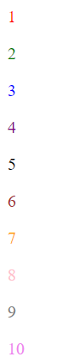

1. Create a HTML document giving details of your name, age, mobile no, address & enrollment no. aligned in proper order?

<html>

<head>

<title> Q3 </title>

</head>

<body bgcolor="pink">

<h1 align='center'>DETAILS</h1>

<p align='left'>NAME : </p>

<p align='right'> SWETHA MURALIDHARAN </p>

<p align='left'>AGE: </p>

<p align='right'>18</p>

<p align='left'>PHONE NUMBER : </p>

<p align='right'> 9994287171</p>

<p align='left'>ADDRESS: </p>

<p align='right'>NO18 , CHERAN GARDEN , BALAJI NAGAR , KALAPATI , COIMBATORE</p>

<p align='left'>ENROLLMENT NUMBER </p>

<p align='right'>20PW35</p>

</body>

</html>

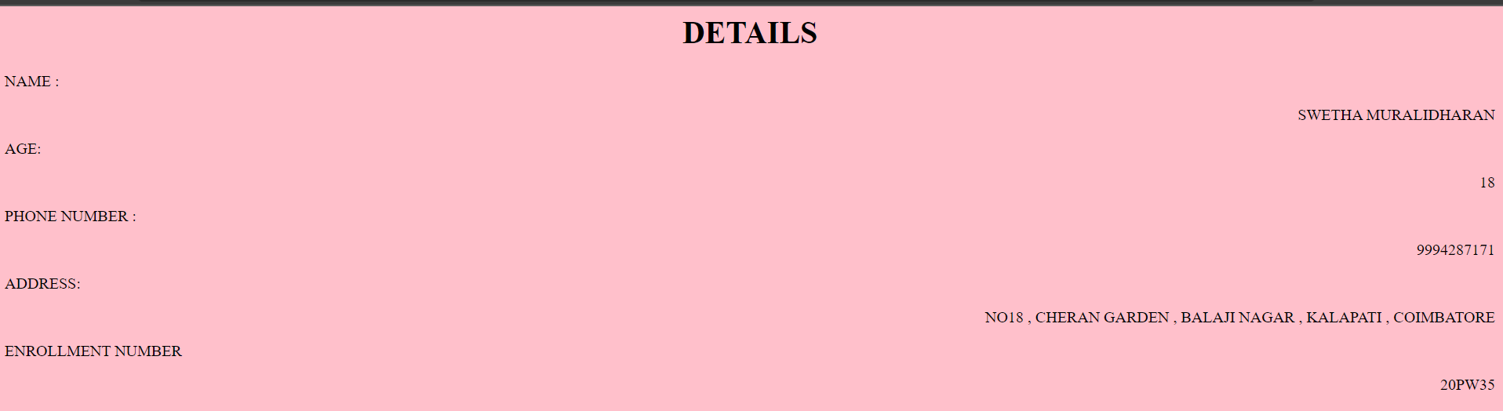

1. Write a HTML code to print your name with different heading style.

<html>

<head>

<title> Q4 </title>

</head>

<body bgcolor="pink">

<h1> SWETHA MURALIDHARAN </h1>

<h2> SWETHA MURALIDHARAN </h2>

<h3> SWETHA MURALIDHARAN </h3>

<h4> SWETHA MURALIDHARAN </h4>

<h5> SWETHA MURALIDHARAN </h5>

<h6> SWETHA MURALIDHARAN </h6>

</body>

</html>

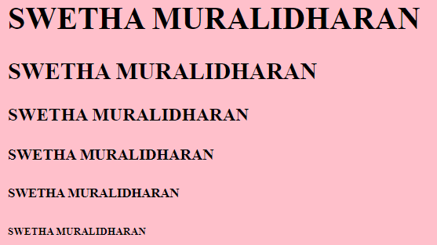

1. Print a paragraph that is a description of a book, include the title of the book as well as its author. Names and titles should be underlined, adjectives should be italicized and bolded.

<html>

<head>

<title> Q5 </title>

</head>

<body bgcolor="pink">

<h1 align='center'><u> HARRY POTTER </u> </h1>

<h2 align='right'><u>J . K. Rowling</u> </h2>

<p> <u> Harry James Potter </u> was an <i> <b> English half-blood wizard </i> </b>, and one of the most famous wizards of modern times. The only child and son of <i> <b> <u> James</u> and <u>Lily Potter</u> </i> </b> , Harry's birth was overshadowed by a <i> prophecy </i>, naming either himself or <u> Neville Longbottom</u> as the one with the power to vanquish <i> <b> <u> Lord Voldemort </u> </i> </b> , the most powerful and feared Dark Wizard in the world. After half of the prophecy was reported to Voldemort, courtesy of <i> <b> <u> Severus Snape </u> </i> </b> , Harry was chosen as the target due to his many similarities with the Dark Lord. In turn, this caused the <i> <b> Potter family </i> </b> to go into hiding. </p>

</body>

</html>

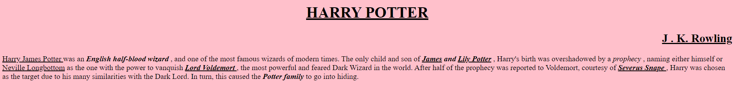

1. Print a paragraph with 4 - 5 sentences. Each sentence should be in a different font.

<html>

<head>

<title> Q6 </title>

</head>

<body bgcolor="pink">

<p> <font face ="Times New Roman ">Most expensive 'Harry Potter' film: ' Harry Potter and the Half-Blood Prince' $250 million budget.</font> </p>

<p> <font face ="Arial Narrow">Longest film in the series: “Harry Potter and the Chamber of Secrets,” 161 minutes.</font> </p>

<p> <font face =" Calibri"> Shortest film in the series: “Harry Potter and the Deathly Hallows:</font> </p>

<p> <font face ="Arial black"> Part 2,” 130 minutes. Longest book in the series: “Harry Potter and the Order of the Phoenix,”</font> </p>

<p> <font face =" Cambria"> 870 pages. Second-shortest film in the series: “Harry Potter and the Order of the Phoenix,” 138 minutes.</font> </p>

</body>

</html>

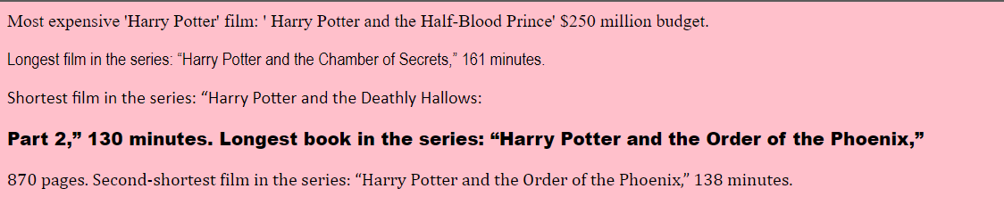

1. Design a page having background color, given text color red and use all the attributes of font tag.

<html>

<head>

<title> Q7.</title>

</head>

<body bgcolor= 'pink' >

<font color="red" face =" ariel" size="5" > <i> Harry potter and the Half-Blood Prince </i> </font>

</body>

</html>

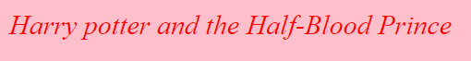

1. Print the squares of the numbers 1 - 20. Each number should be on a separate line, next to it the number 2 superscripted, an equal sign and the result. (Example: 102 = 100)

<html>

<head>

<title> Q8.</title>

</head>

<body bgcolor="pink">

<h3> 1 <sup> 2</sup> = 1 </h3>

<h3> 2 <sup> 2</sup> = 4 </h3>

<h3> 3 <sup> 2</sup> = 9 </h3>

<h3> 4 <sup> 2</sup> = 16 </h3>

<h3> 5 <sup> 2</sup> = 25 </h3>

<h3> 6 <sup> 2</sup> = 36 </h3>

<h3> 7 <sup> 2</sup> = 49 </h3>

<h3> 8 <sup> 2</sup> = 64 </h3>

<h3> 9 <sup> 2</sup> = 81</h3>

<h3> 10 <sup> 2</sup> = 100 </h3>

<h3> 11 <sup> 2</sup> = 121 </h3>

<h3> 12 <sup> 2</sup> = 144 </h3>

<h3> 13 <sup> 2</sup> = 169 </h3>

<h3> 14 <sup> 2</sup> = 196 </h3>

<h3> 15 <sup> 2</sup> = 225 </h3>

<h3> 16 <sup> 2</sup> = 256 </h3>

<h3> 17 <sup> 2</sup> = 289 </h3>

<h3> 18 <sup> 2</sup> = 324</h3>

<h3> 19 <sup> 2</sup> = 361 </h3>

<h3> 20 <sup> 2</sup> = 400</h3>

</body>

</html>

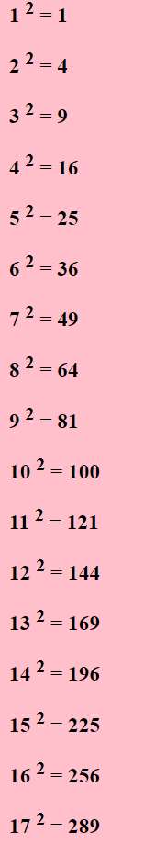

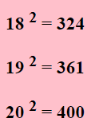

1. Prints 10 names with a line break between each name. The list should be alphabetized, and to do this place a subscripted number next to each name based on where it will go in the alphabetized list. (Example: Alan1). Print first, the unalphabetized list with a subscript number next to each name, then the alphabetized list. Both lists should have an <h1> level heading

<html>

<head>

<title> Q9.</title>

</head>

<body bgcolor="pink">

<h1>Un - Alphabetized list</h1>

HONGJOONG <sub> 2 </sub>

<br>

SEONGHWA <sub> 6 </sub>

<br>

YUNHO <sub> 10 </sub>

<br>

YEOSANG <sub> 9 </sub>

<br>

MINGI<sub> 4 </sub>

<br>

SAN<sub> 5 </sub>

<br>

WOOYOUNG <sub> 8 </sub>

<br>

JONGO<sub> 3</sub>

<br>

ATEEZ <sub> 1 </sub>

<br>

SWETHA SHERLIN <sub> 7 </sub>

<br>

<h1>Alphabetized list</h1>

ATEEZ

<br>

HONGJOONG

<br>

JONGO

<br>

MINGI

<br>

SAN

<br>

SEONGHWA

<br>

SWETHA SHERLIN

<br>

WOOYOUNG

<br>

YEOSANG

<br>

YUNHO

</body>

</html>

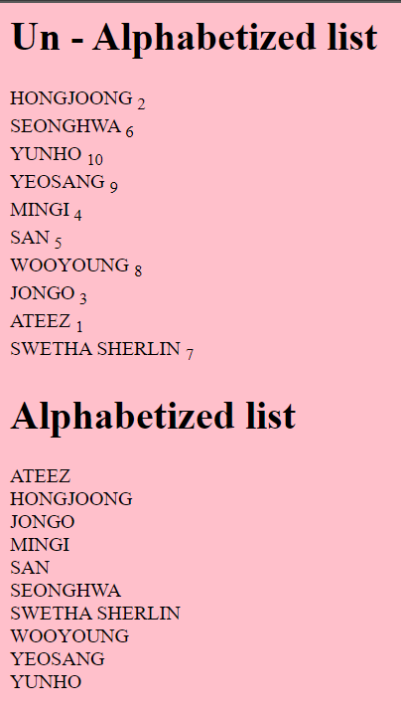

1. Print two paragraphs that are both indented using the &nbsp; command.

<html>

<body bgcolor=”pink”>

<p> &nbsp;&nbsp;&nbsp;&nbsp;&nbsp;&nbsp;&nbsp;&nbsp;&nbsp;&nbsp;&nbsp;&nbsp;&nbsp;&nbsp;&nbsp;&nbsp;&nbsp;&nbsp;&nbsp;&nbsp;&nbsp;&nbsp;&nbsp;&nbsp;&nbsp;&nbsp;&nbsp;Scientists' research has revealed that viruses are by far the most abundant life forms on Earth. There are a million times more viruses on the planet than stars in the universe. Viruses also harbor the majority of genetic diversity on Earth. Scientists are finding evidence of viruses as a planetary force, influencing the global climate and geochemical cycles. They have also profoundly shaped the evolution of their hosts. The human genome, for example, contains 100,000 segments of virus DNA.</p>

<p> &nbsp;&nbsp;&nbsp;&nbsp;&nbsp;&nbsp;&nbsp;&nbsp;&nbsp;&nbsp;&nbsp;&nbsp;&nbsp;&nbsp;&nbsp;&nbsp;&nbsp;&nbsp;&nbsp;&nbsp;&nbsp;&nbsp;&nbsp;&nbsp;&nbsp;&nbsp;&nbsp;Piedmont, or mountain, glaciers are found in many parts of the world. In North America they are distributed along the mountain ranges of the Pacific Coast from central California northward . They abound in the Andes range in South America and are familiar and greatly admired spectacles in the Alps, the Pyrenees, the Caucasus Mountains and the mountains of Scandanavia.</p>

</body>

</html>



1. Print two lists with any information you want. One list should be an ordered list, the other list should be an unordered list.

<html>

<head>

<title> Q11.</title>

</head>

<body bgcolor="pink">

<h3> Things to do <h3>

<ol type = "1" >

<li> Go for a walk </li>

<li> Drink Coffee</li>

<li> buy dress </li>

<li> Talk time with dolls </li>

<li> Prepare for exams</li>

</ol>

<h3> Songs to listen </h3>

<ul>

<li> The real , ateez </li>

<li> hellavator, stray kids </li>

<li> Mic drop , BTS </li>

<li> Pretty savage , Black pink </li>

<li> Jopping, SuperM </li>

</ul>

</body> </html>

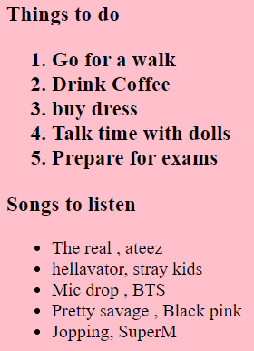

1. Create a HTML document containing three ordered lists: ice cream, soft serve and frozen yogurt. Each ordered list should contain a nested, unordered list of your favorite flavors. Provide a minimum of three flavors in each unordered list.

<html>

<body bgcolor="pink">

<ol>

<li>Icecream</li>

<ul>

<li>vanilla</li>

<li>butterscotch</li>

<li>chocolate</li>

</ul>

<li>Soft serve</li>

<ul>

<li>vanilla</li>

<li>chocolate</li>

<li>caramel</li>

</ul>

<li>Frozen Yogurt</li>

<ul>

<li>strawberry</li>

<li>vanilla</li>

<li>pineapple</li>

</ul>

</ol>

</body>

</html>

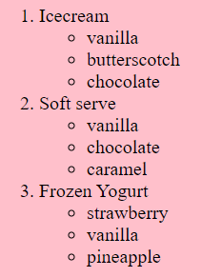

1. Prints an h1 level heading followed by a horizontal line whose width is 100%. Below the horizontal line print a paragraph relating to the text in the heading.

<html>

<body bgcolor="pink">

<h1>JUST LIKE MAGIC</h1>

<hr width="100%">

<p>Magic, sometimes spelled magick is the application of beliefs, rituals or actions employed in the belief that they can manipulate natural or supernatural beings and forces.It is a category into which have been placed various beliefs and practices sometimes considered separate from both religion and science.Although connotations have varied from positive to negative at times throughout history, magic "continues to have an important religious and medicinal role in many cultures today".Within Western culture, magic has been linked to ideas of the Other ,foreignness, and primitivism; indicating that it is "a powerful marker of cultural difference" and likewise, a non-modern phenomenon. During the late nineteenth and early twentieth century, Western intellectuals perceived the practice of magic to be a sign of a primitive mentality and also commonly attributed it to marginalised groups of people./p>

</body>

</html>

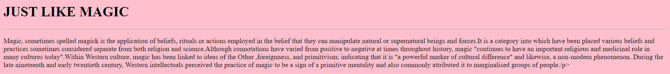

1. Print some preformatted text of your choosing. (hint: use the <pre> tag)

<html>

<body bgcolor="pink">

<p>

<pre>

Hello ,

I am Swetha Muralidharan ,

from Muscat , Oman .

Gald to meet you ....

</pre>

</body>

</html>

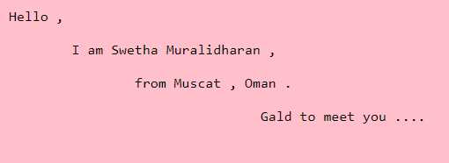

1. Print a long quote and a short quote. Cite the author of each quote.

<html>

<head> <title> q15 </title>

<body bgcolor="pink">

" We have three roles here on earth: to learn,

to love, and to live. When we stop learning, we start to stagnate and die. When we stop loving,

we lose our sense of purpose and become self-centered. When we limit our living, we deny the world

the benefits of our talents " - Jim Cathcart

<br>

<br>

<q>"One faces the future with ones's past"</q> - Pearl S. Buck

</body>

</html>



1. Print some deleted and inserted text of your choosing.

<html>

<head> <title> q16 </title>

<body bgcolor="pink">

<p>My favorite color is <del><font color="red"> red </font> </del><font color="blue"> <ins> blue</ins>! </font> </p>

</body>

</html>



1. Print a definition list with 5 items.

<html>

<head>

<title> Q17 </title>

<body bgcolor='pink'>

<dl>

<dt>KPOP</dt>

<dd>Kpop is an abbreviation of Korean Pop or Korean Popular Music. The term K-pop refers to the popular genre of music originating from the country of South Korea. </dd>

<dt>KDRAMA</dt>

<dd>Korean drama more popularly known as K-dramas, are television series in the Korean language, made in South Korea. </dd>

<dt>BTS</dt>

<dd> South Korean hip-hop boy group </dd>

<dt>ATEEZ</dt>

<dd>ATEEZ is an 8-member group under KQ Entertainment. The group consists of: Hongjoong, Seonghwa, Yunho, Yeosang, San, Mingi, Wooyoung, and Jongho.</dd>

<dt>STRAY KIDS</dt>

<dd>Stray Kids usually means being amazing all around and hard working.</dd>

</dl>

</body>

</html>

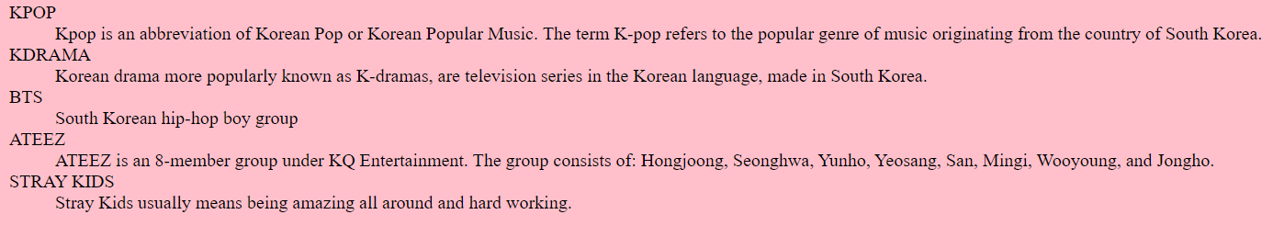

1. Print two addresses in the same format used on the front of envelopes (senders address in top left corner, receivers address in the center).

<html>

<head>

<title> Q18 </title>

<body bgcolor='pink'>

<address>

No 18<br >

cheran garden

balaji nagar <br>

kalapatti ,

coimbatore -641048 </address>

<br><br >

<center>

<address>

<br >

F2 flat <br >

subash street ,

anandha nagar,<br>

east thambaram ,<br>

chennai -600059

</address>

</center>

</body>

</html>

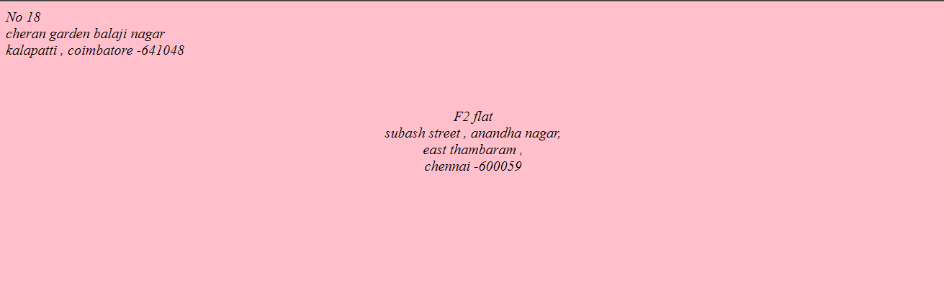

1. Print ten acronyms and abbreviations of your choosing, each separated by two lines. Specify the data that the abbreviations and acronyms represent.

<html>

<body bgcolor="pink">

<p> ABBREVIATION </p>

<abbr title="Korean Pop or Korean Popular Music.">KPOP</abbr>

<br>

<abbr title="Korean drama or K-drama "> KDRAMA </abbr>

<br>

<abbr title="As soon as possible">A.S.A.P. </abbr>

<br><abbr title="Approximately"> Approx. </abbr>

<br>

<abbr title="Born to Beat;"> BTOB </abbr>

<br>

<p> ACORNYM </p>

<acronym title="A TEEnager Z " >ATEEZ</acronym>

<br>

<acronym title="Personal Identification Number">PIN</acronym>

<br>

<acronym title="BANGTAN SONYEONDAN ">BTS</acronym>

<br>

<acronym title="TOMORROW BY TOGETHER">TXT</acronym>

<br>

<acronym title="Light Amplification by the Stimulated Emission of Radiation.">LASER</acronym>

<p>

Move your mouse over an abbreviation or acronym to get more data.

</p>

</body>

</html>

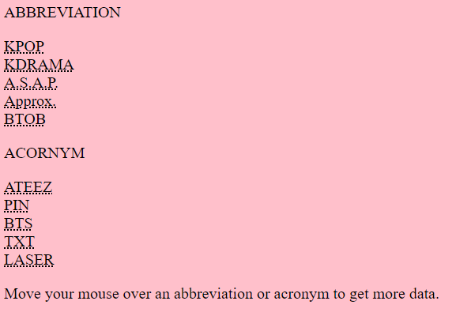

1. Write a HTML code to create a web page of blue color and display links in red color.

<html>

<body bgcolor="blue">

<ul>

<li> <a href = "https://www.youtube.com/watch?v=nlnMDttgTbk"> <font color="red"> ATEEZ - Deja Vu </font> </a> </li> <br>

<li> <a href = "https://www.youtube.com/watch?v=WpuatuzSDK4"> <font color="red"> SEVENTEEN - Rock with you </font> </a> </li> <br>

<li> <a href = "https://www.youtube.com/watch?v=X7d6Dt17yHk"> <font color="red"> Enhyphen - Fever </font> </a> </li> <br>

<li> <a href = "https://www.youtube.com/watch?v=kTlv5_Bs8aw"> <font color="red"> BTS - Mic drop </font> </a> </li><br>

</ul>

</body>

</html>

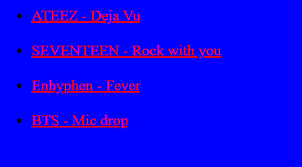

1. Create some links to various search engines (google, yahoo, altavista, lycos, etc).

<html>

<head>

<title> Q21 </title>

</head>

<body bgcolor="pink">

<ul>

<li> <a href = "https://www.google.co.in/"> <font color="red"> GOOGLE </font> </a> </li> <br>

<li> <a href = "https://www.youtube.com/"> <font color="red"> YOUTUBE </font> </a> </li> <br>

<li> <a href = "https://in.search.yahoo.com/?fr2=inr"> <font color="red"> YAHOO </font> </a> </li> <br>

<li> <a href = "http://www.bing.com"> <font color="red"> BING </font> </a> </li><br>

<li> <a href = "http://www.weather.com"> <font color="red"> TODAY WEATHER</font> </a> </li><br>

</ul>

</body>

</html>

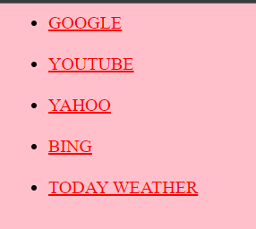

1. Create links to five different pages on five different websites that should all open in a new window.

<html>

<head>

<title>Q22</title>

</head>

<body bgcolor="pink">

<ul>

<li> <a href="https://www.google.co.in/" target="_blank">GOOGLE </a> </li><br>

<li> <a href="http://www.youtube.com/" target="_blank">YOUTUBE</a> </li><br>

<li> <a href="https://in.search.yahoo.com/?fr2=inr"" target="_blank">YAHOO </a> </li><br>

<li> <a href="http://www.bing.com" target="_blank">BING</a> </li><br>

<li> <a href="http://www.weather.com" target="_blank">TODAY WEATHER </a> </li><br>

</body>

</html>

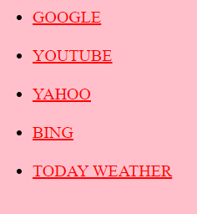

1. Create a page with a link at the top of it that when clicked will jump all the way to the bottom of the page. At the bottom of the page there should be a link to jump back to the top of the page.

<html>

<head>

<title> Q23 </title>

</head>

</title>

<body bgcolor="pink">

<a name="top">The top of the page</a> <br>

<a href="#bottom">Click here to jump to the bottom of the page</a>

<p>Q1.</p>

<p>Q2.</p>

<p>Q3.</p>

<p>Q4.</p>

<p>Q5.</p>

<p>Q6.</p>

<p>Q7.</p>

<p>Q8.</p>

<p>Q9.</p>

<p>Q10.</p>

<p>Q11.</p>

<p>Q12.</p>

<p>Q13.</p>

<p>Q14.</p>

<p>Q15.</p>

<p>Q16.</p>

<p>Q17.</p>

<p>Q18.</p>

<p>Q19.</p>

<p>Q20.</p>

<p>Q21.</p>

<p>Q22.</p>

<p>Q23.</p>

<p>Q24.</p>

<p>Q25.</p>

<a name="bottom">The bottom of the page</a> <br>

<a href="#top">Click here to jump to the top of the page</a>

</body>

</html>

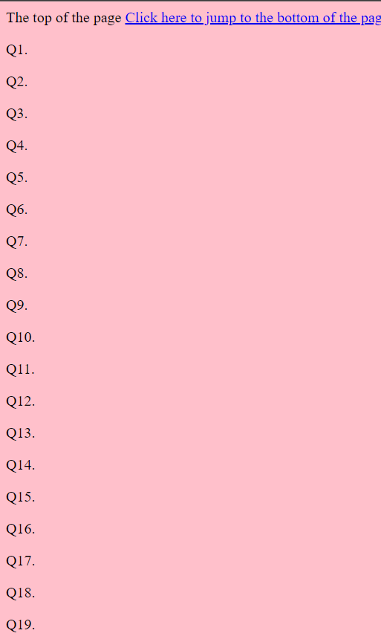

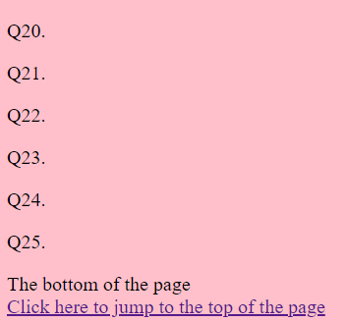

1. Design a web page to display five different images. Skip two lines between each image. Each image should have a title. Also, display each image that has a border of size 2, a width of 200, and a height of 200.

<html>

<head>

<title>Q24</title>

</head>

<body>

<img src="E:\Web designing lab/BTS.jpg" width="200" height="200" alt="BTS" title="BTS" border="2" />

<br>

<br>

<img src="E:\Web designing lab/ATEEZ.jpg" width="200" height="200" alt="ATEEZ" title="ATEEZ" border="2"/>

<br>

<br>

<img src="E:\Web designing lab/STRAY KIDS.jpg" width="200" height="200" aalt="STRAY KIDS" title="STRAY KIDS" border="2" />

<br>

<br>

<img src="E:\Web designing lab/TXT.jpg" width="200" height="200" a alt="TXT" title="TXT" border="2" />

<br>

<br>

<img src="E:\Web designing lab/ENHYPHEN.jpg" width="200" height="200" a src="ENHYPHEN" title="ENHYPHEN" border="2"/>

</body>

</html>

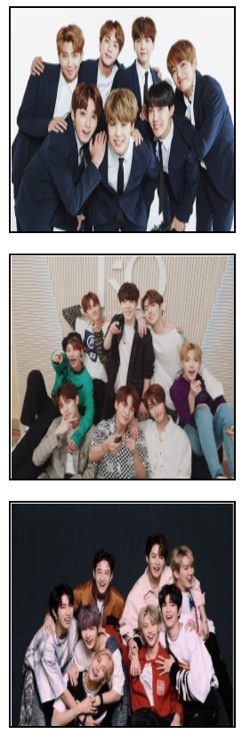

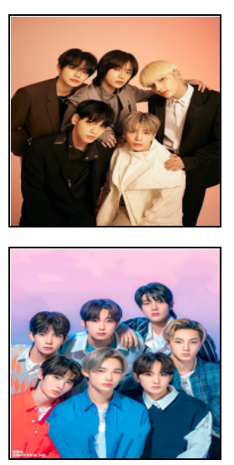

1. Design a web page with two images, when the first image clicked will link to a search engine of your choice (should be opened in a new window) and when the second image clicked will link to itself and will display the image in the browser by itself.

<html>

<head>

<title>Q25</title>

</head>

<body>

<a href="https://ibighit.com/bts/eng/" target="_blank">

<img src="E:\Web designing lab/BTS.jpg" width="400" height="300" alt="BTS" title="BTS" border="2" />

<p>

CLICK TO VISIT BIGHIT WEBSITE

</p>

<br>

<br>

<a href="http://kqent.com/producer/1594" target="_top">

<img src="E:\Web designing lab/ATEEZ.jpg" width="400" height="300" alt="ATEEZ" title="ATEEZ" border="2"/>

<p>

CLICK TO VISIT KQ ENTERTAINMENT WEBSITE

</p>

</body>

</html>

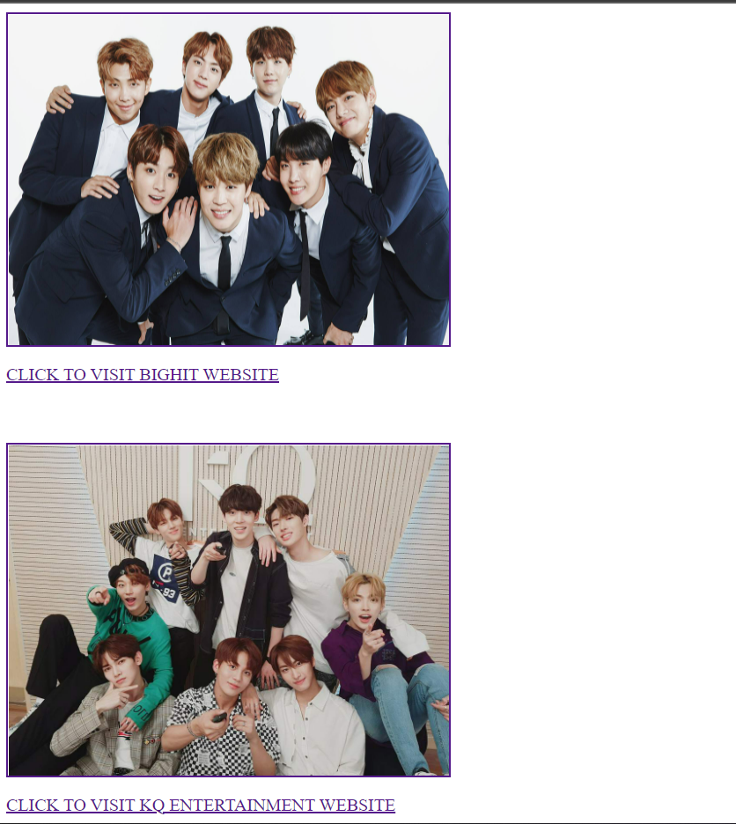

1. Design a web page as shown below using text formatting elements and lists:

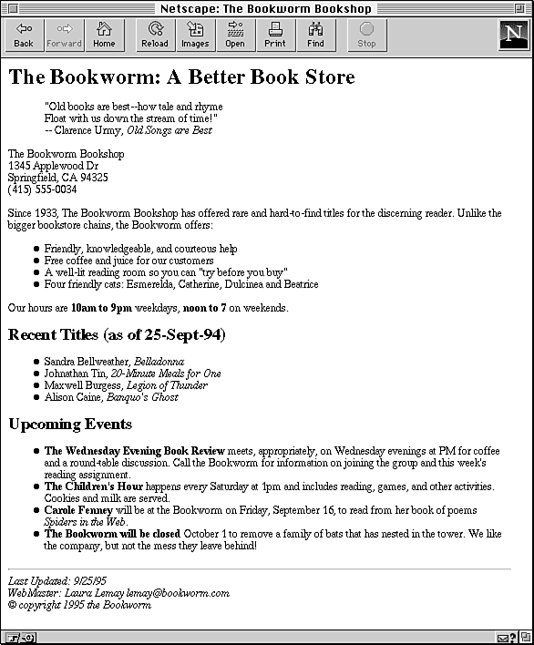

<html>

<body>

<h1>The Bookworm: A Better Book Store</h1>

<p align = "center"><blockquote>"Old books are best - how tale and rhyme

<br>Float with us down the stream if time!</blockquote>

</blockquote> --Clarence Urmy, Old Songs are Best</p>

<p>The Bookwrm Bookshop<br>1345, Applewood Dr<br>Springfield, CA 94325<br>

(415) 555-0034</p>

<p>Since 1933, The Bookworm Bookshop has offered rare d hard to find titles for the discerning readers . Unlike the <br>

bigger bookstore chains , the Bookworm offers: </p>

<ul>

<li>Friendly, knowlegable and courteous help</li>

<li>Free coffee and juice for our customers</li>

<li>A well-lit reading room so you can "try before you buy"</li>

<li>Four friendly cats:</li>

</ul>

<p>Our hours are <b>10am to 9pm</b> weekdays, <b>noon to 7</b> on weekends</p>

<h1>Recent Titles (as of 25-Sept-94)</h1>

<ul>

<li>Sandra</li>

<li>Johnathan</li>

<li>Maxwell Burgress</li>

<li>Aluison Caine</li>

</ul>

<h1>Upcoming Events</h1>

<ul>

<li><b>The Wednesday Evening Book Review </b> meets</li>

<li><b>The Children's Hour</b> happens</li>

<li><b>Carole Fenny</b> will be at the Bookworkm on Friday</li>

<li><b>The Bookworm will be closed</b> October 1 to remove a family of bats</li>

</ul>

<hr>

<address>Last updated<br>Web Master: Laura Lemary lermay@bookworm.com<br>

Copyright 1995 the Bookworm</address>

</body>

</html>

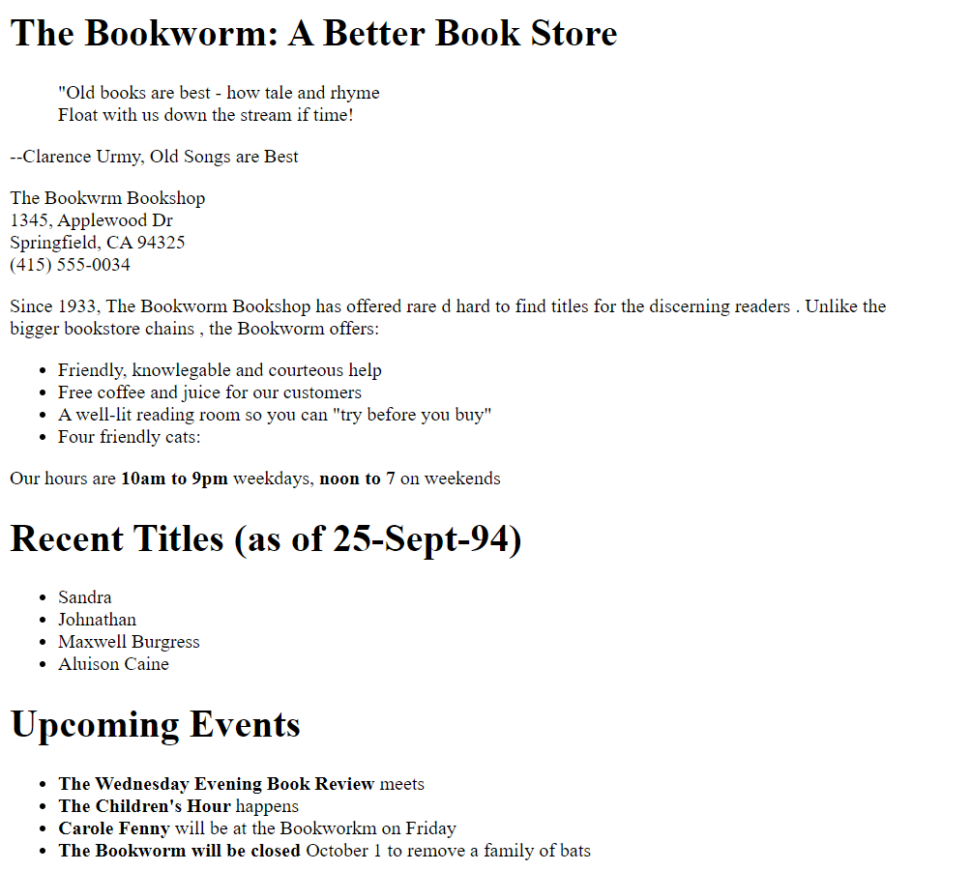

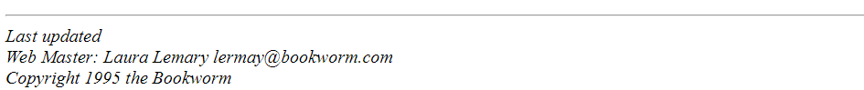

1. Design a web page as shown below using text formatting elements:

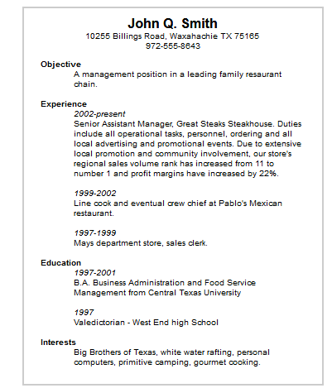

<html>

<body>

<center><h1>John Q. Smith</h1>

<p>10255 Billings Road, Waxahachie TX 75165<br>

972-555-8643</p></center>

<dl>

<dt><b>Objective</b></dt> <dd>A management position in a leading family restaurant chain</dd>

</dl>

<dl>

<dt><b>Experience</b></dt> <dd><i>2002-present</i><br>Senior Assisstabnt Manager

<br><br> <i>1999-2002</i><br>Line cook and eventual crew chief

<br><br><i>1997-1999</i><br>Mays departement store, sales clerk

</dd>

</dl>

<dl>

<dt><b>Education</b></dt> <dd>

<i>1997-2001<br></i>Business Administration..<br><br>

<i>1997</i><br> Valedictorian - West End high school

</dd>

</dl>

<dl>

<dt><b>Interest</b></dt> <dd>Big brothers od Texas</dd>

</dl>

</body>

</html>

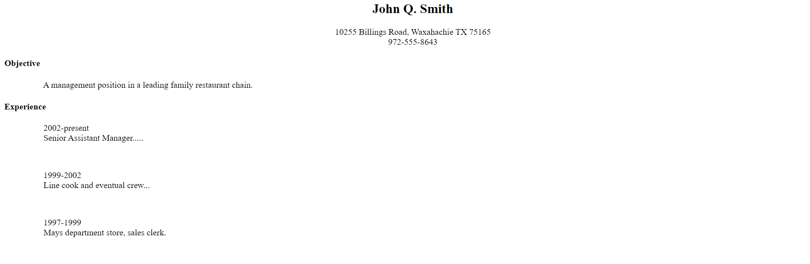

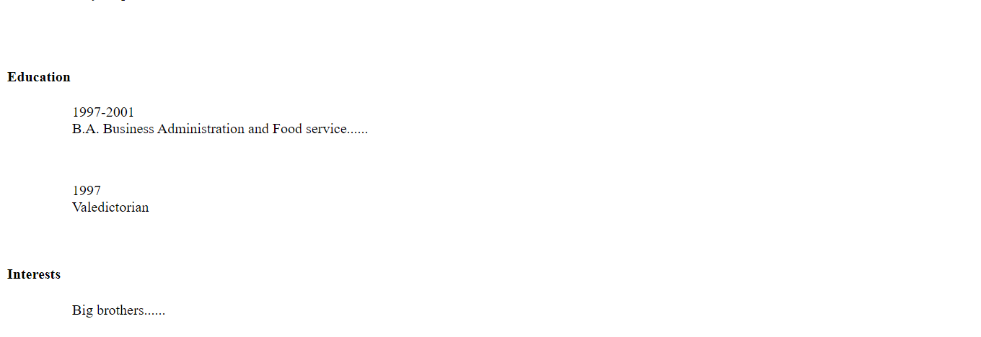

1. Design the below table using HTML with background image and also with real time data (atleast five records).

|  |  |  |  |  |  |  |
| --- | --- | --- | --- | --- | --- | --- |
| Train No. | Name of the Train | Place | Destination | Time | | Fare |
| Arrival | Departure |
| …. |  |  |  |  |  |  |
| …. |  |  |  |  |  |  |

<html>

<body>

<table border = '1' style = "table-layout:fixed; width:930px">

<colgroup>

<col style = "width: 79px">

<col style = "width: 141px">

<col style = "width: 124px">

<col style = "width: 94px">

<col style = "width: 99px">

<col style = "width: 190px">

<col style = "width: 203px">

</colgroup>

<thead>

<tr>

<th>Train</th>

<th>Name of the train</th>

<th>Place</th>

<th>Destination</th>

<th colspan="2">Time</th>

<th colspan="2">Fare</th>

</tr>

<tr>

<th colspan="4"></th>

<th>Arrival</th>

<th>Departure</th>

</tr>

</thead>

<tbody>

<tr>

<td>33742</td>

<td>Exp A</td>

<td>Chennai</td>

<td>Kanyakumnari</td>

<td>9:00</td>

<td>14:30</td>

<td>500</td>

</tr>

<tr>

<td>33284</td>

<td>Exp B</td>

<td>Coimbatore</td>

<td>Chennai</td>

<td>6:00</td>

<td>15:00</td>

<td>600</td>

</tr>

<tr>

<td>33287</td>

<td>Exp C</td>

<td>Delhi</td>

<td>Chennai</td>

<td>7:00</td>

<td>23:00</td>

<td>800</td>

</tr>

<tr>

<td>33874</td>

<td>Exp D</td>

<td>Mumbai</td>

<td>Chennai</td>

<td>7:00</td>

<td>17:00</td>

<td>980</td>

</tr>

<tr>

<td>33187</td>

<td>Exp E</td>

<td>Chennai</td>

<td>Bengaluru</td>

<td>9:00</td>

<td>20:00</td>

<td>750</td>

</tr>

</tbody>

</table>

</body>

</html>

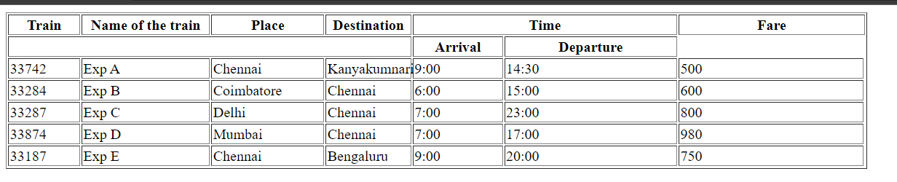

1. Write a HTML code to design a table filled with images in each cell.

|  |  |  |  |
| --- | --- | --- | --- |
| 1 | 2 | 3 | 4 |
| 5 | Image | | 6 |
| 7 | 8 |
| 9 | 10 | 11 | 12 |

<html>

<head>

<meta charset="UTF-8">

<meta http-equiv="X-UA-Compatible" content="IE=edge">

<meta name="viewport" , initial-scale="4.0">

<title>Q29</title>;

</head>

<style>

img{

height: 100px;

width: 100%;

}

.center{

height: 200px;

}

</style>>

<body>

<table>

<tr>

<td><img src="E:\Web designing lab/img1.jpg" alt = 1></td>

<td><img src ="E:\Web designing lab/img2.jpg" alt = 2></td>

<td><img src = "E:\Web designing lab/img3.jpg" alt = 3></td>

<td><img src = "E:\Web designing lab/img4.jpg" alt = 4></td>

</tr>

<tr>

<td><img src = "E:\Web designing lab/img5.jpg"alt = 5></td>

<td rowspan = "2" colspan = "2"><img class = "center" src = "E:\Web designing lab/img13.jpg" alt = 13></td>

<td><img src = "E:\Web designing lab/img6.jpg" alt = 6></td>

</tr>

<tr>

<td><img src = "E:\Web designing lab/img7.jpg"alt = 7></td>

<td><img src = "E:\Web designing lab/img8.jpg" alt = 8></td>

</tr>

<tr>

<td><img src = "E:\Web designing lab/img9.jpg" alt = 9></td>

<td><img src = "E:\Web designing lab/img10.jpg" alt = 10></td>

<td><img src = "E:\Web designing lab/img11.jpg" alt = 11></td>

<td><img src = "E:\Web designing lab/img12.jpg" alt = 12></td>

</tr>

</table>

</body>

</html>

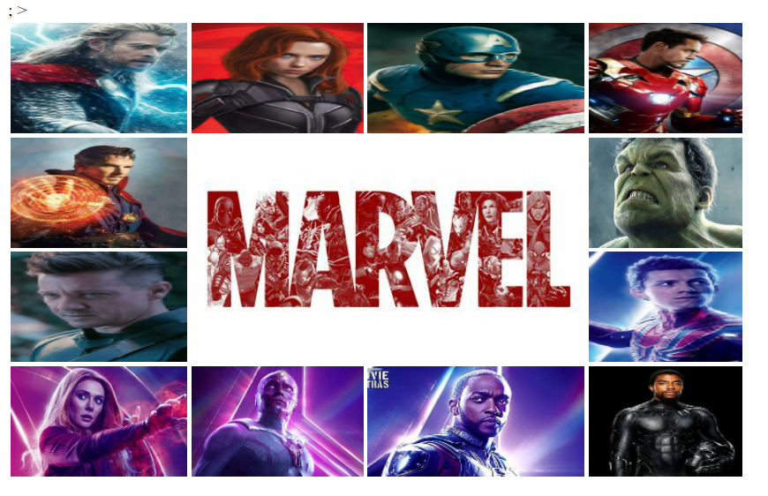

1. Design the below table shows the seminar schedule

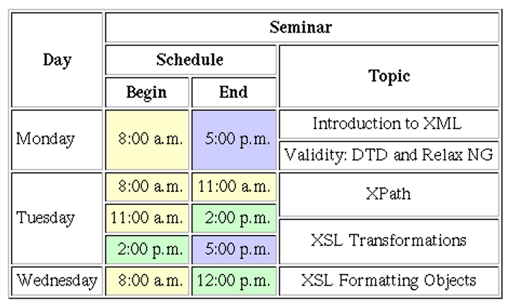

<html>

<head>

<title>HTML Table Cellpadding</title>

</head>

<body >

<table border="1" cellpadding="5" cellspacing="5" align="center" height="400" width="700">

<tr>

<th rowspan="3" ><font size="50px">DAY</font></th>

<th colspan="3">SEMINAR</th></tr>

<tr>

<th colspan="2">SCHEDULE</th>

<th rowspan="2">TOPIC</th>

<tr>

<th>BEGIN</th><th>END</th>

</tr>

<tr>

<td rowspan="2">MONDAY</td>

<td rowspan="2" bgcolor="yellow">8:00 a.m.</td>

<td rowspan="2" bgcolor="lavender">5:00 p.m.</td>

<td >Introduction to XML</td>

<tr><td >Validity: DTD and Relax NG</td>

tr>

<td rowspan="3">TUESDAY</td>

<td bgcolor="yellow">8:00 a.m.</td>

<td bgcolor="yellow">11:00 a.m.</td>

<td >XPath</td><tr>

<td bgcolor="yellow">11:00 a.m.</td>

<td bgcolor="lightgreen"> 2:00 p.m.</td>

<td rowspan="2"> XSL Transformatics</td>

<tr><td bgcolor="lightgreen">2:00 p.m.</td>

<td bgcolor="lavender">5:00 p.m.</td>

</tr>

<tr>

<td>WEDNESDAY </td>

<td bgcolor="yellow">8:00 a.m.</td>

<td bgcolor="lightgreen ">12:00 p.m.</td>

<td>XSL Formatting Objects</td>

</tr>

</table>

</body>

</html>

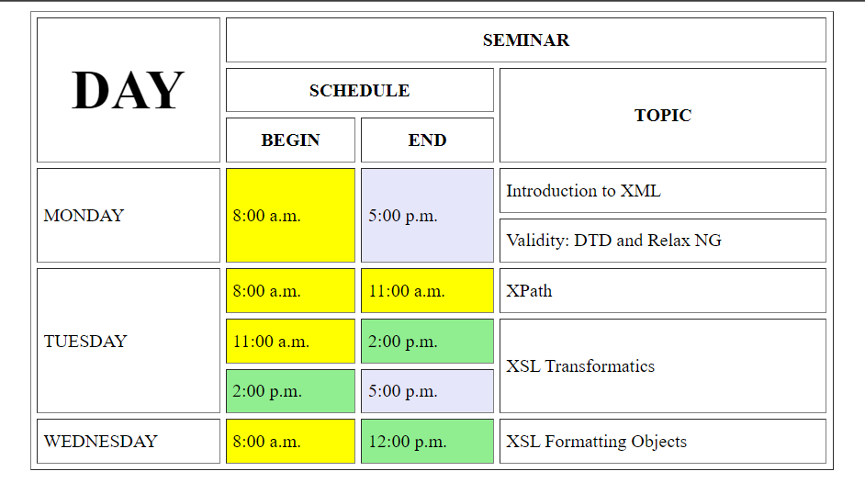

1. Design a home with the contents shown below using Nested tables

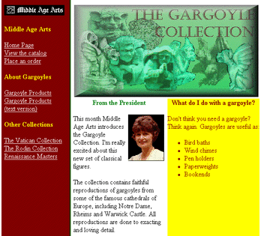

**Web Resources:**

1. [*https://www.quackit.com/html/tutorial/introduction.cfm*](https://www.quackit.com/html/tutorial/introduction.cfm)
2. [*https://www.w3schools.com/html/*](https://www.w3schools.com/html/)
3. [*https://www.tutorialspoint.com/html/*](https://www.tutorialspoint.com/html/)
4. [*http://htmldog.com/guides/html/*](http://htmldog.com/guides/html/)

<head>

</head>

<body>

<table>

<tr>

<td rowspan="2" bgcolor="brown">

<img src="E:\Web designing lab/image1.jpg" alt="logo" />

<h4 bgcolor="yellow">Middle Age Arts</h4>

<a href="#">HomePage</a><br>

<a href="#">View the Catlog</a><br>

<a href="#">Place an order</a><br>

<h4 color="yellow">About Gargoyles</h4>

<a href="#">Gargoyle Products</a><br>

<a href="#">Gargoyle Products</a><br>

<a href="#">(text version)</a><br>

<h4 color="yellow">Other Collections</h4>

<a href="#">The Vatican Collection</a><br>

<a href="#">The Rodin Collection</a><br>

<a href="#">Renaissance Masters</a><br>

</td>

<td colspan="2" style="height: 233px;">

<img height="100px" width="600px" src="E:\Web designing lab/image2.jpg" alt="banner" />

</td>

</tr>

<tr>

<td width="200px">

<h4 color="green" align="center">From the President</h4>

<img src="E:\Web designing lab/image3.jpg"" alt="photo" />

<p>This month Middle Age Arts introduces the Gargoyle Collection. I'm really excited about this new set

of classical figures.</p>

<p>

The collection contains faithful reproductions of gargoyles from some of the famous cathedrals of

Europe, including Notre Dame, Rheims and Warwick Castle. All reproductions are done to exacting and

loving detail.</p>

</td>

<td bgcolor="#FFFF00" width="200px" align="top">

<h4 bgcolor="brown" align="center">What can you do with a gargoyle?</h4>

<p bgcolor="brown">

Don't think you need a gargoyle? Think again. Gargoyles are useful as:</p>

<ul bgcolor="brown">

<li>Bird baths</li>

<li>Wind chimes</li>

<li>Pen holders</li>

<li>Paperweights</li>

<li>Bookends</li>

</ul>

</td>

</tr>

</table>

</body>

</html>